How to start the instance in random port
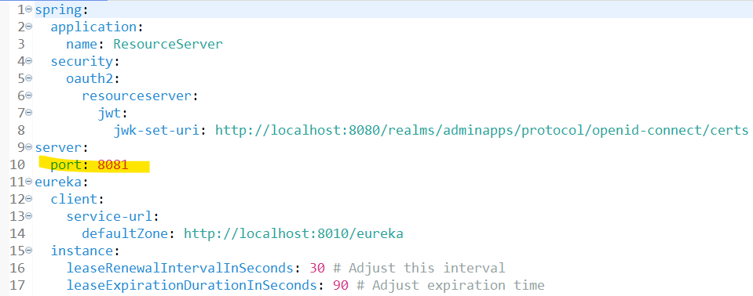

We change this port to: 0

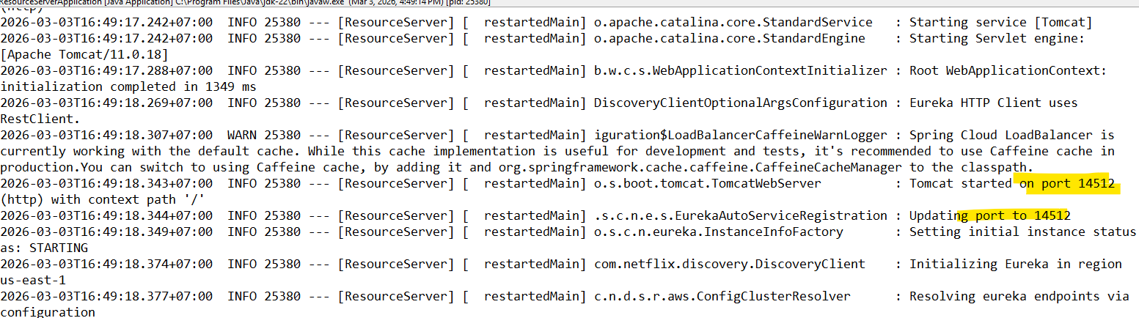

- Configure instance

ពេលដែលយើង ​start new instance the Eureka Discovery វាចាប់យកតែមួយទេហើយអាមួយ Run ចុងក្រោយគេ ចឹងដើម្បីធ្វើអោយ Eureka អាចកំណត់ new instance បានយើងត្រូវ configure new instance in the Service របស់យើង
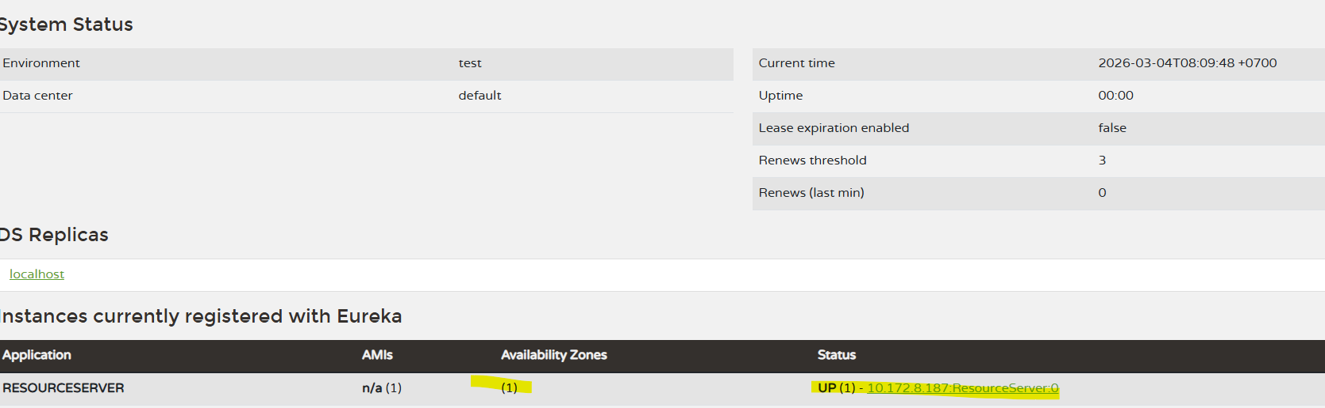

យើងមើល port វាបានដោយចុតទៅកាន់ Link instance នឹងបាន
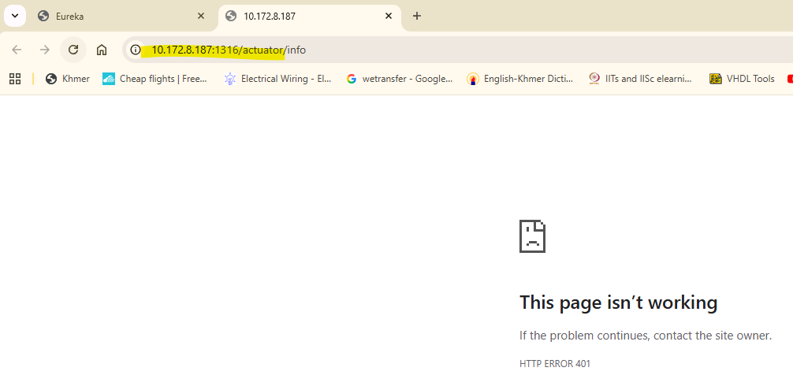

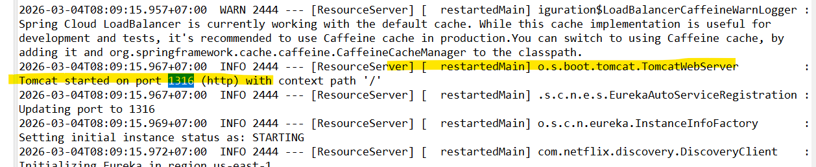

Solution:
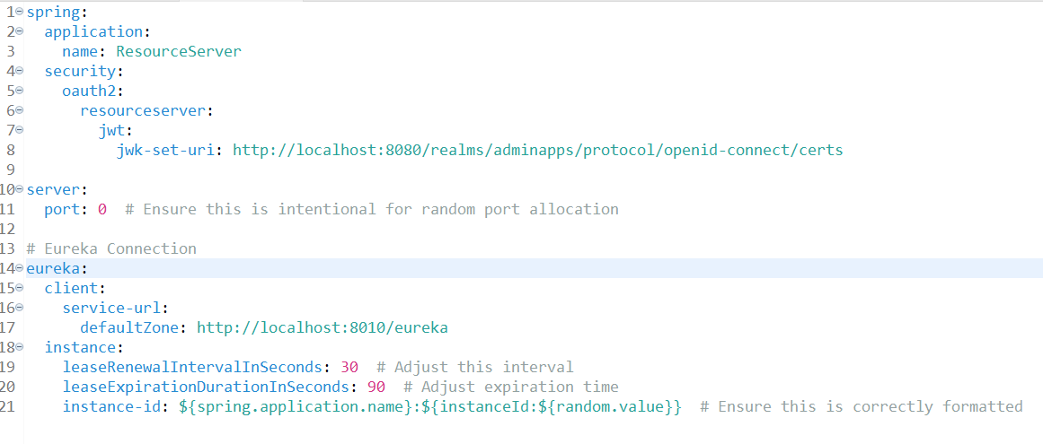

eureka:
client:
service-url:
defaultZone: http://localhost:8010/eureka
instance:
leaseRenewalIntervalInSeconds: 30 # Adjust this interval
leaseExpirationDurationInSeconds: 90 # Adjust expiration time
instance-id: ${spring.application.name}:${instanceId:${random.value}} # Ensure this is correctly formatted

ដោយអោយវាចាប់ Random port number(difference id)

Issue we have random id on the Eureka and difficult to identify:
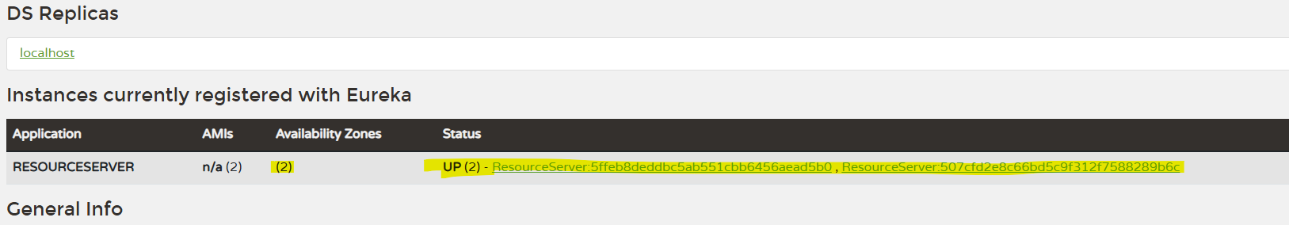

- Two: Instance of the resource Server

